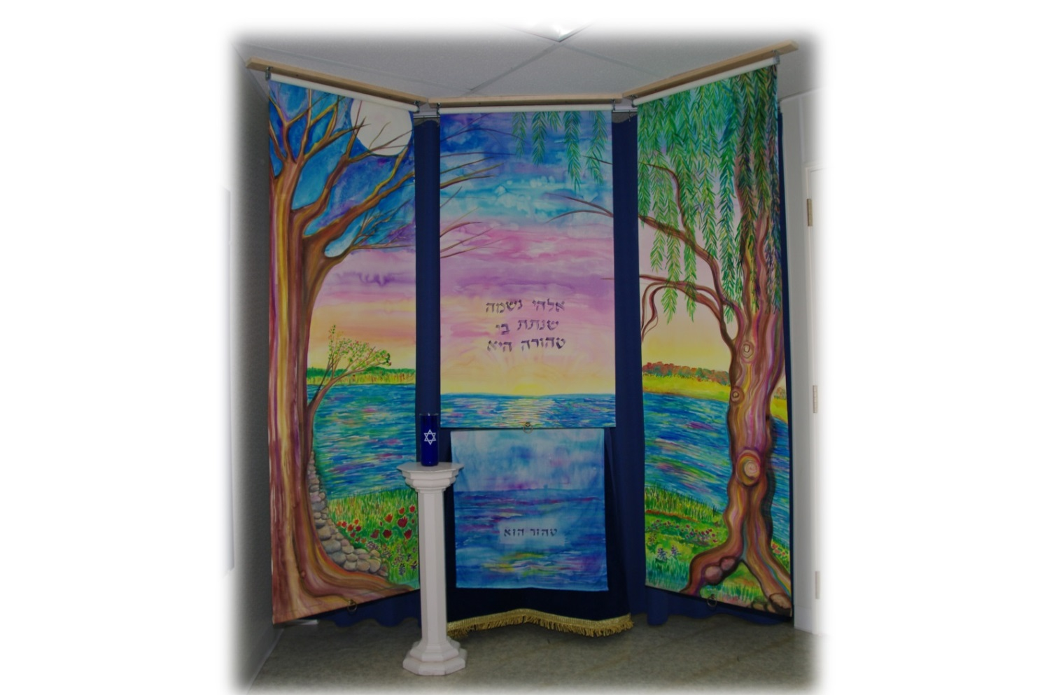
Photo by Scott Gordon

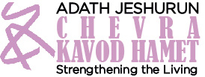

Shomrim Handbook

Everything you wanted to know about sitting shmira, and more!

Chevra Kavod Hamet
Adath Jeshurun Congregation
Minnetonka, MN
Rev. May 2022

Table of Contents

Table of Contents 1
Glossary 3
Description of Shmira 4
Shomer/Shomeret Volunteer Role Description 6
Shomrim Instructions 9
Funeral home location 9
Map to funeral home 9
Shmira room location 10
Accessibility 10
Emergency phone calls after-hours 11
May non-members of Adath sit shmira? 12
May non-Jews sit shmira? 12
Do shomrim sit alone or with another person? 12
I’ve never sat shmira before and I’m a little nervous about it. 12
When shomrim should arrive for their shift 13
What to wear when sitting shmira 13
Will shomrim see the met/metah? 13
Special artwork in the shmira room 13
Restrooms 14
Water fountain 14
Electrical outlets 14
Keeping the shmira room doors open or closed 14
When you arrive at and exit the funeral home during work hours 15
If you are the first shomer/shomeret in this episode of sitting shmira 15
At the beginning of the shift 15
Sh'ma 16
What TO DO while sitting shmira 17
Shomrim journal 17
Please leave the shomrim room books and other reading material in the room 17
What TO AVOID while sitting shmira 17
If there is more than one met/metah 18
At the end of the shift 19
IMPORTANT – Blowing out the shiva candle 19
Shomrim who are sitting overnight 20
Air bed for shomrim sitting overnight 20
Entering the building after hours 21
Exiting the building after hours and SPECIAL CAUTION 22
IF THIS SHOULD HAPPEN… 23
PROBLEM: Something in the shmira room seems out of order. 23
PROBLEM: The met/metah is not present. 23
PROBLEM: The light of the shiva candle has gone out. 24
PROBLEM: The shiva candle is missing or the candle in the jar has been used up. 24
PROBLEM: The waste basket by the wash station by the door is full. 24
PROBLEM: The water pitcher on the wash station by the door is empty or nearly empty. 24
PROBLEM: The dish bin for catching water on the wash station by the door is getting full of water. 25
PROBLEM: The paper towel holder on the wash station by the door is empty or nearly empty. 25
PROBLEM: I’m not sure whether another shomer/shomeret is supposed to follow me when I leave. 25
PROBLEM: The person who is supposed to follow me is late and has not contacted me. It’s after hours and if I leave before the next person arrives, he/she will not be able to get into the building. 25
PROBLEM: Who can I call with general questions or concerns? 26
APPENDIX 27
Picture of complete installation of three-part decorative screen 27
Artists’ Description – A Pure Soul; Screen for the Chevra Kavod Hamet 28
The Cycle of Paintings of the Prague Burial Society 29
Washburn-McReavy set-up of shmira room 30
Air bed for shomrim sitting overnight 32
Washing hands and the blessing over washing hands 33
Blow out the candle sign 34

Glossary

Aron | Casket
Kippah | Head covering
Kippot | Plural form of kippah
Met | Male deceased
Metah | Female deceased
Neshama | Spirit or soul
Shomer | Male sitting shmira
Shomeret | Female sitting shmira
Shomrim | Multiple males or multiple males and females sitting shmira
Shomrot | Multiple females sitting shmira
Shiva candle | White candle in the tall, blue candleholder. Mourners burn the candle for seven days (hence the name “shiva”, from the Hebrew word for seven), but when used in the funeral home it is only burned when a met/metah is present.
Shmira | Guarding or watching
Tahara | Ritual purification

Description of Shmira

Sitting Shmira (Guard/Watch)

One of the valuable services provided by the Chevra is to provide shomrim (guards/ watchers) to sit with the deceased until the time of burial (“sit shmira”).

Shmira demonstrates respect, honor and dignity for the deceased and gives comfort to family members in knowing their loved one is not alone. Out of our busy lives, the small amount of time that a volunteer sits shmira can mean the world to the family at a time when they are emotionally distraught and vulnerable.

Shomrim perform the highest level of Chesed Shel Emet – a selfless act of loving-kindness for which the deceased cannot thank them. The family is not given the names of those who sit shmira, thus they cannot thank the shomrim, either. Traditionally, volunteers sit shmira regardless of whether they know the deceased or the family.

There are a couple of beliefs supporting the Jewish tradition that a deceased not be left alone prior to burial.

There is a strong belief that the neshama (soul) leaves the body after death and hovers over the body from death until burial, and is aware of all that happens to and around the met/metah (male/female deceased). The practice of sitting shmira gives comfort to the neshama while in transition. At burial, the neshama returns to God. “[When dust returns to dust] the spirit shall return to God, who gave it” (Ecclesiastes 12:7).

Just as the Torah Ark retains its holiness after the scroll is removed, the body which contained the sacred soul before death is considered sacred after the neshama departs. To leave a body alone after death would suggest it is now useless and no longer of value. Guarding/watching the body continuously until burial demonstrates respect, honor, and dignity for the deceased.
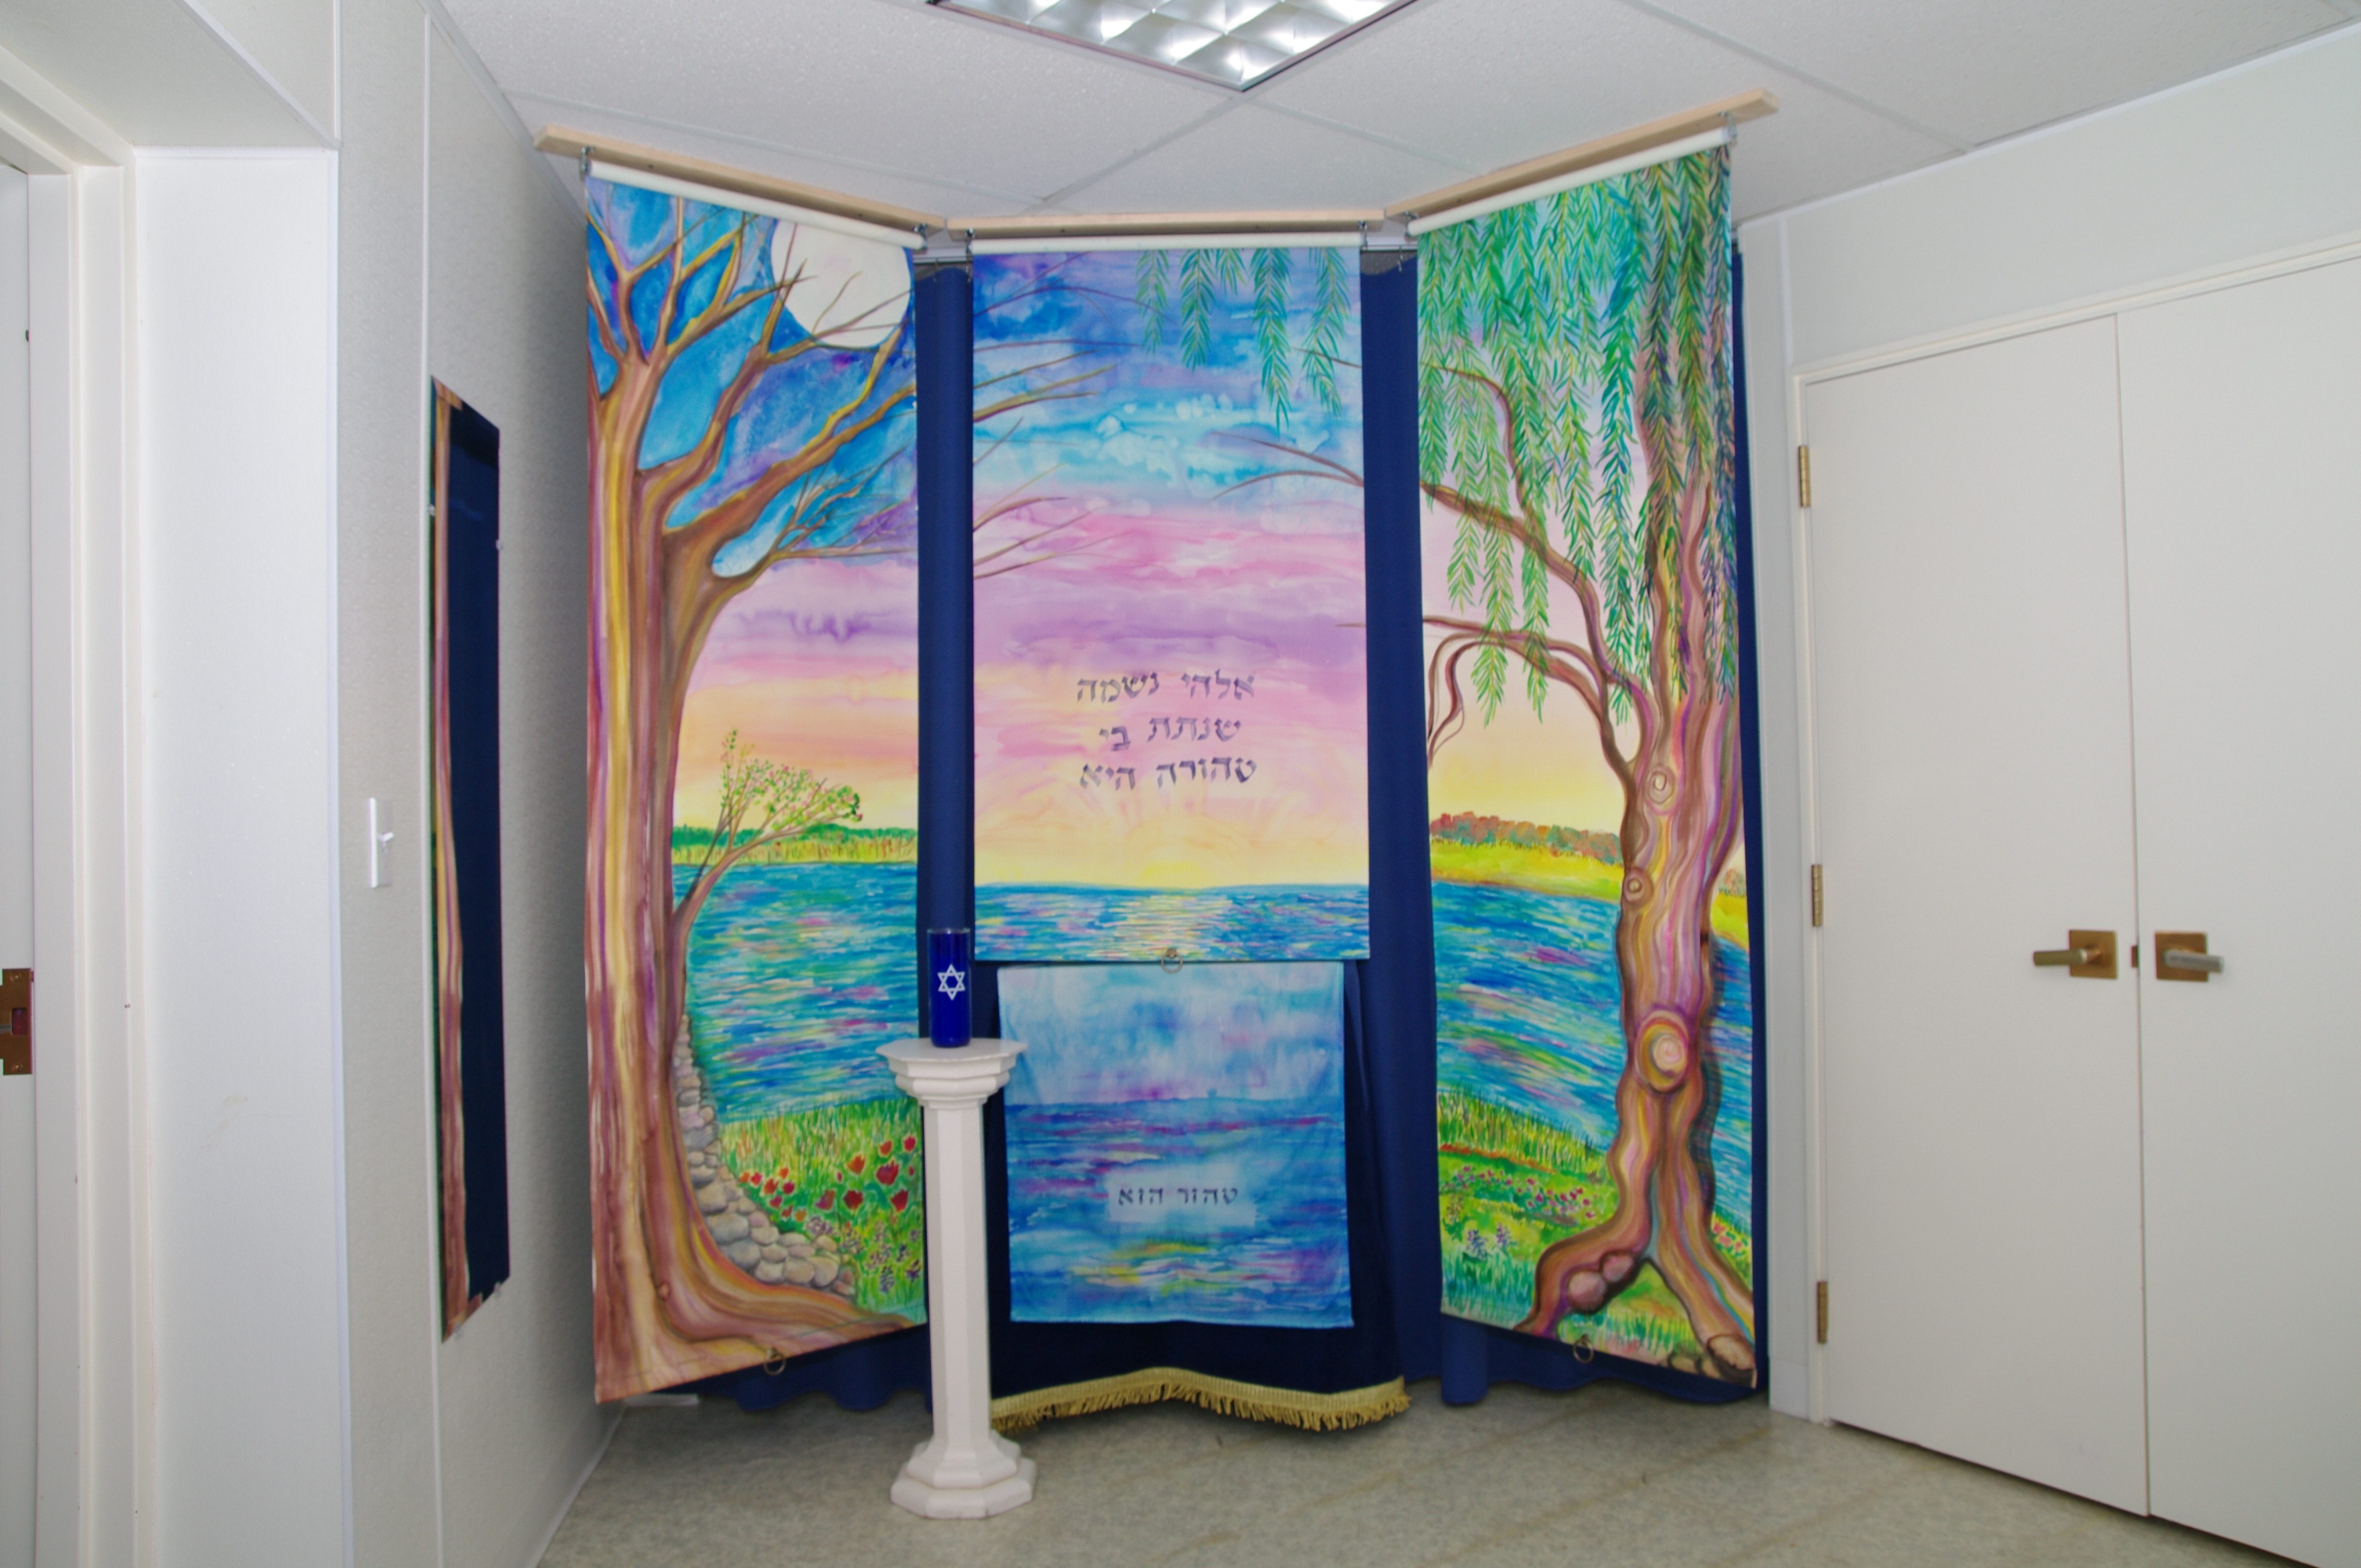
Photo by Scott Gordon
View of the scene while sitting shmira.
The shomrim sit in view of the covered met/metah (male/female deceased), usually in two-hour shifts, and may sit alone or with another person.

The shomrim focus on shmira and read or recite from the Book of Job, Psalms, or contemporary texts on spirituality or Jewish traditions on end-of-life and mourning, or engage in reflection, meditation, or prayer. Appropriate reading material is provided in the shmira room or shomrim may bring their own reading material in character and content with the purpose of sitting shmira.

We ask that shomrim do not eat; drink; chew gum; vape, smoke, or chew tobacco; take a nap; use cell phones, computers, or other electronic devices (no phone calls, texts, emails, social media, etc.); take pictures or videos; read newspapers, magazines, or novels; do homework or projects for work; and to not engage in small talk if they are sitting with another person. We avoid these activities out of respect for the dead, who can no longer do these things, and it contributes to keeping the room a sacred space while sitting shmira.

When burial is arranged through the Chevra Kavod Hamet, the Chevra phones and emails volunteers to sit shmira. Volunteers contact the designated Shmira Arranger to schedule their shift. An individual who has not sat shmira before can arrange with the Shmira Arranger to sit with an experienced shomer/shomeret (male/female guard/watcher).

Family, friends and congregants not on the Chevra volunteer list may arrange to sit shmira for a particular deceased, if they wish. Shomrim do not have to be members of Adath.

Non-Jewish family members or friends may sit shmira. They are expected to wear a kippah and to follow the same protocols as for Jewish shomrim, except they do not recite the Sh'ma or the prayer at the end of the shift, and they do not wash hands or recite the blessing over washing hands when they leave.

The Chevra does the best it can to provide shomrim from the time the met/metah (male/female deceased) arrives at the funeral home until transported to the funeral service. We appreciate any participation in shmira by family and friends of the deceased in addition to other volunteers. We may not be able to provide coverage through the night if shomrim are not available. The timing of Shabbat and holidays may limit our ability to recruit shomrim.

We welcome you to participate in this meaningful mitzvah. To learn more, please call the Adath office at 952.545.2424 or email the Chevra at adathchevra@gmail.com to add your name to the shmira phone and/or email list or to obtain contact information for the Shmira Arranger.

Rev. May 2022

Shomer/Shomeret Volunteer Role Description

Volunteer Role Description
Role Title: | Shomer/Shomeret
Date: | January 2020

Purpose: The shomer/shomeret sits shmira when an Adath congregant passes away and receives the services of the Chevra Kavod Hamet.

Shmira is conducted from the time the met/metah arrives at the funeral home until it is time to leave for the funeral.

Glossary:
Met | Male deceased
Metah | Female deceased
Shomer | Male sitting shmira
Shomeret | Female sitting shmira
Shomrim | Multiple males or multiple males and females sitting shmira
Shomrot | Multiple females sitting shmira
Shmira | Guarding or watching

Location: Shmira is conducted in the lower level of the funeral home in a room dedicated for that purpose.

Washburn-McReavy Funeral Chapel
Edina Chapel
5000 West 50th St.
Edina, MN 55436

Accessibility: The funeral home and shmira space are accessible for people using walkers, canes, or wheelchairs, or who have difficulty managing stairs.

Key Responsibilities:
- Responds to a phone call and/or email requesting volunteers to sit shmira.
- Schedules a shmira shift(s) with the Shmira Arranger.
- Sits shmira at the funeral home according to the Shomrim Instructions.
- Experienced shomrim may accompany and instruct novice shomrim on their role.
- Maintain confidentiality and anonymity.

Reports to: Chevra Kavod Hamet leadership team.

Confidentiality: To protect the privacy of the deceased and the family, the Shomer/Shomeret does not discuss the identity of scheduled shomrim, when, how many volunteers have sat shmira or any other related information to anyone other than Chevra leadership.

Anonymity: Consistent with the tradition that the shomrim do not expect or request thanks for performing the mitzvah of sitting shmira, the Shomer/Shomeret does not reveal to the family of the deceased the identify of volunteers who sat shmira for their loved one.

Length of Appointment: The shomer/shomeret serves as frequently and for as many months or years as he/she is willing and available.

Time Commitment: There are approximately 15-17 opportunities for shomrim to volunteer each year, with a cadre of volunteers taking turns as Shomer/Shomeret over the course of the year. Each episode as shomer/shomeret usually involves sitting a two-hour shift, although some shomrim only sit for one hour, some sit multiple shifts, and some sit overnight. The shifts can occur any time of day or night, as the shomer/shomeret is willing and available.

Qualifications: Commitment and passion to the mission and work of the Chevra, patience, and dependability.

Support: Written instructions and verbal review of instructions for this position are provided. In addition, the Chevra leadership team members and the Shmira Arranger are available to answer questions and provide assistance.

Age Requirement: Adult or older teenager. Teenagers under age 18 may accompany an adult sitting shmira.

Dress Code: Casual attire is acceptable. Some people come dressed for work if coming directly from or going directly to work.

Development Opportunities: The shomer/shomeret may serve in other volunteer positions within the Chevra as desired, concurrently with or before or after becoming a shomer/shomeret.

Role Requirements:
- Must be able to spend dedicated time sitting a shift(s) at the funeral home.
- While sitting shmira, must conduct himself/herself in a manner befitting the role of shomer/shomeret, according to the Shomer/Shomeret Instructions.

Role Challenges: No advance notice of need, must refrain from using electronic devices and social media while sitting shmira.

Role Benefits: Sense of satisfaction in the knowledge that you comfort the family and honor the deceased by helping to ensure that shomrim are sitting with the deceased at the funeral home, the honor of being present in the final journey of the deceased, development of a greater respect for matan chaim (the gift of life), and a deeper sense of the spirituality that Judaism attaches to death and the preparation for burial.

Related Documents:
Shomrim Handbook

Shomrim Instructions

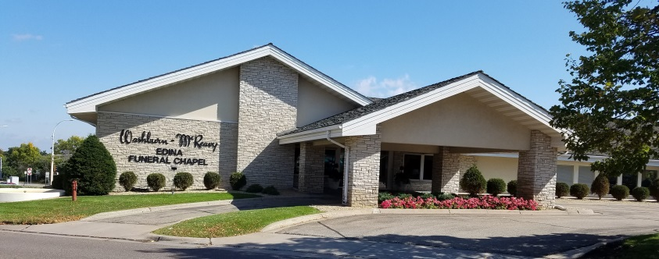

Funeral home location

Washburn-McReavy Funeral Chapel
Edina Chapel
5000 West 50th St.
Edina, MN 55436
24 hour #: 952-920-3996

Map to funeral home

The Washburn-McReavy Funeral Chapel is located on the southwest corner of Hwy 100 and West 50th Street in Edina.

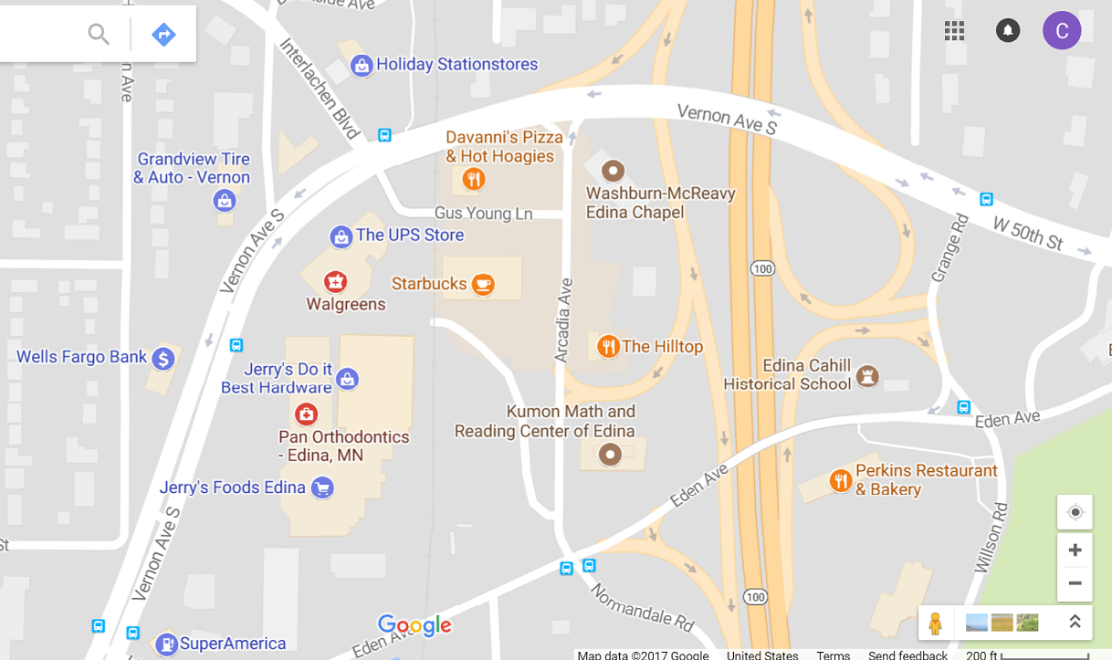

Shmira room location

Shmira is conducted in the lower level of the funeral home in a room dedicated for that purpose. The shmira space is accessible – See the “Accessibility” section.

The shmira room is adjacent to the prep room where tahara is performed, but shomrim do not see the prep room. There is a curtain and decorative three-part screen dividing the two areas.

Accessibility

The shmira space is accessible for people using walkers, canes, or wheelchairs, or who have difficulty managing stairs. A standard size wheelchair easily fits through all the doors.

There are two ways to get to the shmira room that do not require using stairs:
- Enter the building through the people door by the garage door. The garage is located along the back of the building, facing the frontage road/Hwy 100 entrance ramp. Press the doorbell by the door to let the current shomer/shomeret or funeral home staff knows you are there. If entering through the people door by the garage door, shomrim must pre-arrange with the current shomer/shomeret or funeral home staff so they know to expect them.
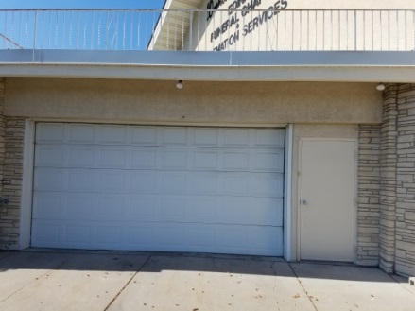

  - To get to the garage from the shmira room, exit the door of the shmira room by the table with the sign-in book and enter the door to the left. This door opens directly to the garage. OR
  - To get to the garage from the shmira room, exit the door of the shmira room by the storage closets and enter the door to the right. This door opens directly to the garage.

- Enter the building through the main entrance and use the elevator to get downstairs

There is an accessible restroom on the lower level and drinkable water is available from the faucet in the kitchenette by the restrooms. There are usually cups on the counter or in the drawers or cupboard of the kitchenette.

To get from the shmira room to the downstairs restrooms/kitchenette/elevator:
- Exit the shmira room through the door by the storage closets.
- Immediately turn left and go straight through the casket showroom.
- At the end of the room, enter the door on the right and go through the headstone/marker/vault showroom.
- Go straight through the social hall.
- The elevator is straight ahead through the social hall.
- The restrooms and kitchenette are on your left just before the staircase.

To get from the elevator to the downstairs restrooms/kitchenette and shmira room:
- Go through the social hall.
- The restrooms and kitchenette will be on your right just after the staircase.
- Go through the headstone/marker/vault showroom.
- Go straight through the casket showroom.
- Immediately turn right and enter the door into the shmira room.

Emergency phone calls after-hours

Options in an emergency, depending on the situation:
- Use your cell phone to call 911.
- Use a funeral home landline to call 911. Press a button for other than the “Main” line to get out of the funeral home phone system. There is no need to dial “9” to get out of the system.
- Use a funeral home landline to reach the funeral home after-hours answering person (this person is off-site, not at the Edina Chapel). Using a funeral home landline, press the button for the “Main” line and the after-hours answering person will pick up the phone from an outside location.

The phones are located:
- On the lower level – In the garage on the wall and in the lower level office space (the office door is usually closed after hours, but it is OK to enter to use the phone).
- On the upper level – In any of several office and meeting room spaces.

May non-members of Adath sit shmira?

Non-members of Adath are welcome and encouraged to sit shmira. Their presence will provide comfort to the neshama and the family of the deceased as much as Adath members sitting shmira.

May non-Jews sit shmira?

Non-Jewish relatives and friends are welcome and encouraged to sit shmira. Their presence will provide comfort to the neshama and the family of the deceased as much as Jewish friends and relatives.

Non-Jews sitting shmira are expected to wear a kippah and to follow the same protocols as for Jewish shomrim, except they do not recite the Sh'ma or the prayer at the end of the shift, and they do not wash hands or recite the blessing over washing hands when they leave.

Do shomrim sit alone or with another person?

Shomrim may sit alone or with another person or persons. Volunteers sitting for the first time may be scheduled with an experienced shomer/shomeret if desired.

When two or more shomrim are sitting together, they should refrain from chatting, gossip, and small talk and focus on the purpose of sitting shmira. See the “What to do while sitting shmira” and “What to avoid while sitting shmira” sections.”

I’ve never sat shmira before and I’m a little nervous about it.

Volunteers sitting for the first time may be scheduled with an experienced shomer/shomeret if desired. This can be arranged with the Shmira Arranger when you call to schedule your shift.

When shomrim should arrive for their shift

Please arrive a few minutes before your shift starts. Please call the person you are replacing if you are going to be late. This is especially important after hours when we are dependent on a continuous presence for one person to let the next one into the building.

What to wear when sitting shmira

Casual attire is acceptable. Some people come dressed for work if coming directly from or going directly to work. Consider bringing a sweater or light jacket as some people find the shmira room to be a bit chilly at times.

Will shomrim see the met/metah?

Shomrim do not see the met/metah.

Prior to tahara, the met/metah will be lying on a table or cart and covered with a cloth. Shomrim can see only the outline of the body under the cloth.

As part of tahara the met/metah is placed in the aron and the aron is covered with a cloth. Shomrim will see the aron covered with a cloth.

Special artwork in the shmira room

There are several pieces of art in the shmira room. Please take note of two particularly important items.

- “The Cycle of Paintings of the Prague Burial Society” – Located on the wall immediately to the right as you enter the shmira room.
- “A Pure Soul” three-part decorative screen – Surrounding the met/metah, located to the left as you enter the room. The artist description is located in an acrylic stand on the table with the sign-in book.

See the Appendix of this handbook for more information on these pieces of art.

Restrooms

The restrooms are located on the right side of the long hallway after entering the building.

To get to the restrooms from the shmira room, take the stairs by the door to the shmira room up to the main level. Go down the long hallway toward the main door. The restrooms are located on the left side of the hallway coming from this direction.

Water fountain

The water fountain is located by the restrooms on the right side of the long hallway after entering the building.

To get to the water fountain from the shmira room, take the stairs by the door to the shmira room up to the main level. Go down the long hallway toward the main door. The water fountain is located on the left side of the hallway coming from this direction.

Electrical outlets

The closest electrical outlet is located just outside the door to the shmira room in the hallway across from the stairs. There are no electrical outlets in the shmira room, so shomrim will not be able to charge cell phones or use the air bed electric pump in the shmira room.

Keeping the shmira room doors open or closed

Shomrim may keep the doors to the shmira room open or closed as desired. Most people keep the doors closed, but it can get a little stuffy in the room and it helps to open the doors occasionally for a few minutes. However…

Keeping the shmira room doors open when funeral home staff is present may result in unexpected disruptions to the peaceful shmira experience.

The funeral home does not use the shmira room or prep room; the space is exclusively used by the Chevra with one exception – When the Chevra is not using the space, the funeral home uses the space as a shortcut between the stairs and their downstairs office space. There is “Stop. Do Not Disturb.” signage visible on the doors when they are closed. If the doors are open while the Chevra is using the space and while funeral home staff is present, funeral home staff cannot see the signage and they are more likely to inadvertently step into the shmira room while shomrim are sitting.

When you arrive at and exit the funeral home during work hours

If your shift is during work hours when the funeral home staff is present, enter through the main doors. If a funeral home staff person is not immediately present, someone is likely to be in an office, located on the left side of the long hallway. Announce your presence (say “Hello” as you walk down the hall). A funeral home staff person can direct you to the area where we sit shmira.

If your shift is during evening or night hours when the funeral home staff is not present, the person currently sitting shmira will let you in. See the “How to Enter the Building After Hours” section for more detail.

Shomrim may exit the building using the people door by the garage door, the double doors at the end of the hallway on the main floor, or the main doors on the main floor. Be sure to pull on the door knob or door handles from the outside to be certain the door is completely closed.

If you are the first shomer/shomeret in this episode of sitting shmira

- If the shiva candle is not lit, use the lighter on the table to light the candle.
- Start a new page in the sign-in book on the table. Refer to previous pages in the book as a model if needed.
  - In the upper right corner of the page write the name of the deceased; date and time of funeral (or as much of this as you know).
  - List your name and shmira date and times on the page You may sign in as “Anonymous” if you wish.

At the beginning of the shift

- If the shiva candle is not lit, use the lighter on the table to light the candle.
- List your name and shmira date and times in the sign-in book. You may sign in as “Anonymous” if you wish.
- Place a kippah on your head if not already wearing one. There is a supply of kippot and bobby pins/clips in the basket on the table.
- While standing and facing the met/metah, recite the first paragraph of the Sh'ma, written below.

Sh'ma

Deuteronomy 6:4-9
Sh'ma Yis'ra'eil Adonai Eloheinu Adonai echad.
Hear, Israel, the Lord is our God, the Lord is One.
Recited quietly:
Barukh sheim k'vod malkhuto l'olam va'ed.
Blessed be the Name of God’s glorious kingdom forever and ever.
V'ahav'ta eit Adonai Elohekha b'khol l'vav'kha uv'khol naf'sh'kha uv'khol m'odekha.
And you shall love the Lord your God with all your heart and with all your soul and with all your might.
V'hayu had'varim ha'eileh asher anokhi m'tzav'kha hayom al l'vavekha.
And these words that I command you today shall be in your heart.
V'shinan'tam l'vanekha v'dibar'ta bam
And you shall teach them diligently to your children, and you shall speak of them
b'shiv't'kha b'veitekha uv'lekh't'kha vaderekh uv'shakh'b'kha uv'kumekha
when you sit at home, and when you walk along the way, and when you lie down and when you rise up.
Uk'shar'tam l'ot al yadekha v'hayu l'totafot bein einekha.
And you shall bind them as a sign on your hand, and they shall be for frontlets between your eyes.
Ukh'tav'tam al m'zuzot beitekha uvish'arekha.
And you shall write them on the doorposts of your house and on your gates.

What TO DO while sitting shmira

Please turn cell phones to mute or off.

Shomrim focus on shmira and read or recite from the Book of Job, Psalms, or contemporary texts on spirituality or Jewish traditions on end-of-life and mourning; engage in reflection, meditation, or prayer. It is traditional to read Psalms while sitting shmira. Appropriate reading material is provided in the shmira room or shomrim may bring their own reading material in character and content with the purpose of sitting shmira. Some shomrim talk to the met/metah or read prayers or Psalms to them.

Shomrim journal

Shomrim are encouraged to write reflections and thoughts in the shomrim journal in the shmira room and to read the existing entries to enhance their experience of sitting shmira. Topics to write about might include stories about the deceased, sitting shmira, funerals, death, dying, mourning, grief, life, the circle of life, caring for members of the Jewish community, Jewish traditions and rituals or related topics. Journal entries may be anonymous if you wish, but please date your entry. . Please write comments and stories in the journal, rather than in the sign-in book.

After use, the journal is to be returned to the acrylic stand on the table with the sign-in book

Please leave the shomrim room books and other reading material in the room

Please leave the shomrim room books and other reading material in the room for use by volunteers performing the mitzvah of sitting shmira. If you want to continue reading the material, check in the Adath library for another copy, check bookstores or Amazon.com and other online sellers, feel free to stop by the funeral home when it is staffed and read in the shmira room, or come back and sit shmira again!

What TO AVOID while sitting shmira

We ask that shomrim do not eat; drink; chew gum; vape, smoke, or chew tobacco; take a nap; use cell phones, computers, or other electronic devices (no phone calls, texts, emails, social media, etc.); take pictures or videos; read newspapers, magazines, or novels; do homework or projects for work; and do not engage in small talk if they are sitting with another person. We avoid these activities out of respect for the dead, who can no longer do these things, and it contributes to keeping the room a sacred space while sitting shmira.

If you must make or take an urgent phone call, please do so in the hallway outside of the shmira room.

If there is more than one met/metah

Once or twice a year we may have two metim/metot in the shmira room, at the same or overlapping times. This does not change anything for the shomrim about sitting shmira, except:

- A page needs to be started in the sign-in book for each.
- Please sign in on both pages when sitting for both.

It is possible, but more rare, that shmira for one met/metah will occur in the usual shmira room and one will occur in a small chapel upstairs. In that case, the first shomer/shomeret sitting upstairs should bring the following items from the shmira room to the chapel upstairs:

- A copy of the Quick Guide to Sitting Shmira. Please leave the Shomrim Handbook downstairs.
- One page from the sign-in book for sign-in upstairs (please leave the book downstairs).
- One or two pens.
- Two or three kippot and bobby pins or clips to be left upstairs while sitting shmira.

Funeral home staff will bring a shiva candle upstairs.

Shomrim will need to use the handwashing station in the shmira room downstairs at the end of their shift. The furniture in the chapels upstairs is not conducive to setting up a handwashing station in those rooms.

At the end of the shift

- Please leave the room in order. Place books on the bookshelf, place trash in the wastebasket, put the journal in the plastic holder, and return the air bed if used (see “Air bed for shomrim sitting overnight” section).

- When the next shomer/shomeret arrives (or if no one is scheduled after you), recite the following prayer while standing and facing the met/metah:

My God, You have created the soul within me; you have formed it.
You breathed it unto me and you preserve it within me.
So long as my soul is within me, I acknowledge You, O Lord.
My God and God of my ancestors, as Master of all creation,
I pray to You, O Lord, who unites soul and body,
That the soul of the (met) (metah), whose body I now leave,
Will find rest in Your sheltering care.
Amen.

- If wearing a Chevra kippah, please leave it in the basket on the table.

- Follow the instructions posted on the wall over the handwashing station for washing your hands and reciting the blessing over washing hands before you leave the room.

- Make sure you have all your possessions before leaving the shmira room – keys, purse, cell phone, sweater, jacket or coat, boots, hat, mittens or gloves, any other items you brought with you. This is especially important if you are the last person at night, as the door will lock behind you when you leave and you will not be able to get back in to retrieve items until funeral home staff returns to work the next morning.

IMPORTANT – Blowing out the shiva candle

The last shomer/shomeret leaving at night when funeral home staff is not present must blow out the shiva candle before leaving. Leaving it burning would create a fire hazard. If funeral home staff is present when leaving, the shiva candle does not have to be blown out.

Shomrim who are sitting overnight

Shomrim who are sitting overnight may sleep at night. If two or more shomrim are sitting overnight together, they should take turns sleeping so that one shomer/shomeret is always awake.

A twin-size air bed is available for use by shomrim who are sitting overnight. See the “Air bed for shomrim sitting overnight” section.

Air bed for shomrim sitting overnight

A twin-size air bed is available for use by shomrim who are sitting overnight (intended for an all-night shift rather than single shifts occurring at night). Shomrim should bring a pillow and blanket if they plan to use the air bed. There is a fabric cover for the bed, but shomrim may bring a set of sheets if they wish.

There is an electric pump for the air bed. The closest outlet is in the hallway across from the stairs, just outside the door to the shmira room; there is no outlet in the shmira room.

The air bed is in a plastic container on the lowest level of the shelf unit immediately to the right on the other side of the drapes. You can get it yourself or ask funeral home staff to get it if staff is present. Be VERY careful not to touch or damage the decorative screen if you get it yourself.

There is a label on the container with instructions to return the air bed, cover, and pump to the container and return the container to the shelf, including how to fold the air bed and cover to so they will fit back into the container.

Entering the building after hours

- Entering at night when funeral home staff is not present:
  - The first night-time shomer/shomeret must arrive while funeral home staff is present. That shomer/shomeret will let the next person in at the end of the shift, and so on.
  - There must be a continuous presence of shomrim to let others in at night as there is no other way to enter the building when staff is not present.
  - On rare occasion a special arrangement may be made for entering the funeral home at night. The Shmira Arranger will inform individual shomrim of any special arrangements.

- Night-time entrances to the building (two options):
  - Garage entrance (preferred): Enter the building through the people door by the garage door. The garage is located along the back of the building, facing the frontage road/Hwy 100 entrance ramp. The shomer/shomeret in the building will walk through the garage to open the people door and let you into the building.

    - To get to the garage from the shmira room, exit the door of the shmira room by the table with the sign-in book and enter the door to the left. This door opens directly to the garage. OR
    - To get to the garage from the shmira room, exit the door of the shmira room by the storage closets and enter the door to the right. This door opens directly to the garage.

  - Main entrance: Once notified by cell phone of the arrival of the next shomer/shomeret, the shomer/shomeret in the building can walk upstairs to open the first set of outside doors near the stairway or the main door to let the arriving shomer/shomeret into the building.

- How incoming shomrim can notify the current shomer/shomeret that he/she has arrived (two options):
  - Garage doorbell (preferred): Ring the doorbell by the people door next to the garage door. The doorbell rings directly into the shmira room. This option is preferred, as it does not involve using a phone and holding a conversation while sitting shmira. If using the doorbell, the incoming shomer/shomeret must use the people door by the garage door to enter the building.
  - Cell phone: This option may be used when entering through the garage and it must be used if the incoming shomer/shomeret is using one of the upstairs doors to enter the building.

The Shmira Arranger will give cell phone numbers of each shomer/shomeret to each other so they can contact each other in case the incoming person is running late or other needs arise for them to contact each other.

Exiting the building after hours and SPECIAL CAUTION

Shomrim may exit the building using the people door by the garage door, the double doors at the end of the hallway on the main floor, or the main doors on the main floor. Be sure to pull on the door knob or door handles from the outside to be certain the door is completely closed.

CAUTION: The outer doors automatically lock behind you after hours, so be absolutely certain you have all your possessions in hand before you leave the building. If there is no funeral home staff present and you are the last shomer/shomeret at night, there is no way to reenter the building until the funeral home staff arrives the next day.

IF THIS SHOULD HAPPEN…

If you go into the prep room on the other side of the blue drapes,
be VERY careful not to touch or damage the decorative shades!

PROBLEM: Something in the shmira room seems out of order.

ANSWER: The proper room arrangement is specified on the posters on the door to the shmira room and in the Appendix of this handbook. There is also a picture of the proper room arrangement in the Appendix. Check the posters and picture to help identify what is out of order. If you feel comfortable doing so, feel free to make necessary adjustments (close the drapes better, move the candle, move the cart the met/metah is lying on, flip the decorative runner on the met/metah to the correct end, etc.) or you can ask the funeral home staff to make the adjustments if staff is present. Be VERY careful not to touch or damage the decorative shades.

PROBLEM: The met/metah is not present.

ANSWER: We do not start sitting shmira until the met/metah is brought to the funeral home, so the met/metah is there, but may have been placed in the prep room behind the blue curtain. If the funeral home staff is present, ask the staff to place and arrange the met/metah properly. If the funeral home staff is not present or if you feel comfortable doing so, place and arrange the met/metah and the room as specified on the posters on the door to the shmira room and in the Appendix of this handbook. There is also a picture of the proper room arrangement in the Appendix.

Be VERY careful not to touch or damage the decorative shades when moving between the shmira room and the prep room. When pulling down the decorative window shades, the shades on the left and right go almost to the floor and the one in the middle ends just over the met/metah. If you are not able to reach the rings on the shades, use the wooden stick with the hook on the end, located against the wall by the mirror, to reach the rings. ** Please handle the shades only by the rings at the bottom to avoid tearing or soiling the shades.

PROBLEM: The light of the shiva candle has gone out.

ANSWER: Use the lighter on the table to light the candle. To operate the lighter, unlock the lighter by sliding the button to the “on” position, then slide or push the button on the top simultaneously while you pull the trigger. Different lighters may operate slightly differently.

PROBLEM: The shiva candle is missing or the candle in the jar has been used up.

ANSWER: There are more shiva candles in the prep room on the other side of the drapes. They are located on the far end of the counter, either sitting on the counter or in the cupboard under the counter on the furthest end, closest to the wall. You may ask funeral home staff to get a new candle if staff is present if you do not feel comfortable going into the prep room.

PROBLEM: The waste basket by the wash station by the door is full.

ANSWER: You can empty the waste basket into the large trash container in the prep room on the other side of the drapes. There are three containers immediately to the left as you enter the prep room; the trash container is on the far right of the three, next to the counter, with a sign on the wall above it identifying it as the trash container. Be sure to use the correct container. You may ask funeral home staff to empty the trash if staff is present if you do not feel comfortable going into the prep room.

PROBLEM: The water pitcher on the wash station by the door is empty or nearly empty.

ANSWER: You can refill the pitcher at the sink in the prep room on the other side of the drapes. Do not fill it more than 2/3 full or it will be too heavy and cumbersome. You may ask funeral home staff to fill the pitcher if staff is present if you do not feel comfortable going into the prep room.

PROBLEM: The dish bin for catching water on the wash station by the door is getting full of water.

ANSWER: You can empty the dish bin in the sink in the prep room on the other side of the drapes. You may ask funeral home staff to empty the dish bin if staff is present if you do not feel comfortable going into the prep room.

PROBLEM: The paper towel holder on the wash station by the door is empty or nearly empty.

ANSWER: There is a supply of paper towels under the sink in the prep room on the other side of the drapes. You may ask funeral home staff to refill the paper towel holder if staff is present if you do not feel comfortable going into the prep room.

PROBLEM: I’m not sure whether another shomer/shomeret is supposed to follow me when I leave.

ANSWER: Call the Shmira Arranger to find out if someone else is supposed to follow you.

PROBLEM: The person who is supposed to follow me is late and has not contacted me. It’s after hours and if I leave before the next person arrives, he/she will not be able to get into the building.

ANSWER: The Shmira Arranger should have given you the cell phone number of the person who is scheduled to follow you. If not, call the Shmira Arranger to get the contact information if it is not too late at night (use your judgement on this). Please stay a few minutes longer to wait for the next shomer/shomeret.

PROBLEM: Who can I call with general questions or concerns?

ANSWER: There are various resources depending on the nature of your questions or concerns.
- If your questions or concerns relate to the environment of the shmira room or the funeral home, the funeral home staff may be able to assist if staff is present.
- If your questions or concerns relate to sitting shmira, contact the Shmira Arranger, or the Chevra leadership team may be able to help: Cindy Dubansky at 612-308-0166 or Joe Peilte at 612-968-7504. Please be respectful of the time of day or night when calling (use your judgement on this).
- If your questions or concerns relate generally to the Chevra, contact the Chevra leadership team: Cindy Dubansky at 612-308-0166 or Joe Peilte at 612-968-7504. Please be respectful of the time of day or night when calling (use your judgement on this).

APPENDIX

Picture of complete installation of three-part decorative screen

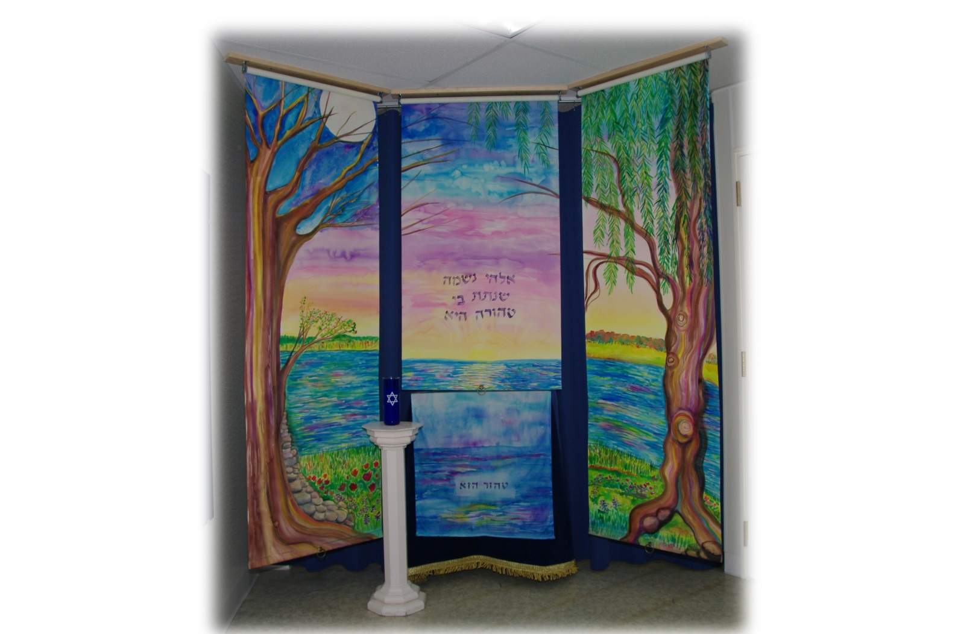
Photo by Scott Gordon

Artists’ Description – A Pure Soul; Screen for the Chevra Kavod Hamet

The Cycle of Paintings of the Prague Burial Society

The Cycle of Paintings of the Prague Burial Society

These history panels from Czech Republic were presented for use
by Shomrim of Chevra Kavod Hamet – Adath Jeshurun Congregation

In Blessed Memory of Jerry S. Zweigbaum by the Zweigbaum Family
Fall, 2001

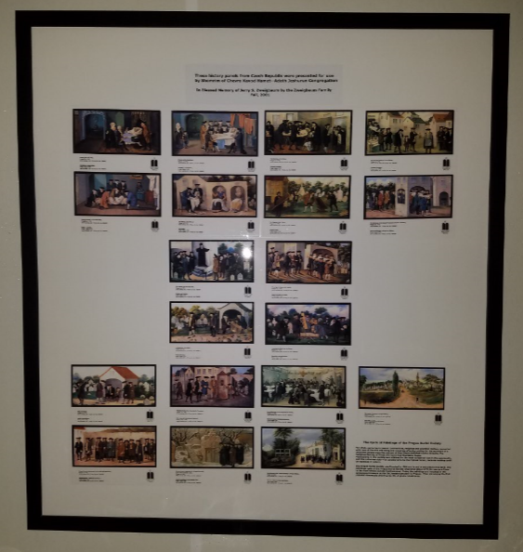

For whole centuries in Jewish communities, religious and practical matters connected with care of the sick and dying and consoling of and providing for the survivors of a deceased person were the concern of the Chevra Kadisha Gomle Hasadim, The Religious Society of Those who Carry Out Charitable Deeds.

Membership in the society was attained by the most esteemed men in the community, and this volunteer duty was considered to be the highest honor, because nothing could be expected in return.

The Prague Burial Society was founded in 1564 and is one of the oldest of its kind. The paintings cycle of the Prague Burial Society originated about 1772 for use as a frieze in the room where society members met. Today the paintings are mounted in the synagogue/museum at the Old Jewish Cemetery in Prague. They are among the first pictorial documents showing the life of ghetto inhabitants.

Washburn-McReavy set-up of shmira room

Air bed for shomrim sitting overnight

Air bed

The pump for the air bed is electric. The closest electrical outlet is located in the hallway across from the stairs, just outside the door to the shmira room; there are no electrical outlets in the shmira room.

Please put the air bed, cover, and pump back into the container when you are done using the bed and put the container back on the shelf. To fit the bed and accessories back into the container:

Air bed:
- Deflate the bed.
- Fold the bed in thirds lengthwise.
- Roll up the bed tightly.

Cover:
- Fold the cover in half lengthwise.
- Fold the cover in half lengthwise again.
- Roll up the cover tightly.

Pump:
- Place the pump on top of the rolled up cover in the container.

Washing hands and the blessing over washing hands

Blow out the candle sign

